Weekly format

[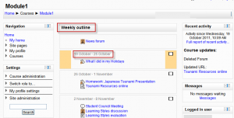](https://docs.moodle.org/31/en/File:Weeklyoutline.png)

Weekly format example

The course is organized week by week, with a clear start date and a finish date. Moodle will create a section for each week of your course. You can add content, forums, quizzes, and so on in the section for each week.

*TIP:* If you want all your students to work on the same materials at the same time, this would be a good format to choose.

*NOTE:* Make sure your course start date is correct. If it is not your weeks will have the wrong date on it. This is especially important if you are restoring a course to use with a new section of students.